**Project Report**

**Online Examination with Face Authentication and Question Paper Generator**

**Introduction:**

This report is going to talk about how we started our project implementation and how we are working towards the project and it mainly talks about creating database of the project and user profiles and organising them.

**Prerequisites:**

For this increment the following mentioned are the pre requisites, we can download them from the chrome or any browser.

Node.js has to be the latest version for better use, you can download it from your browser.

Angular cli has to be installed in node.js using certain commands.

You can create a firebase account online in firebase site.

The code editor can be downloaded from the browser and you have install node.js into it to run the application later.

These are only pre requisites for the part that done in first increment, the required tools for further project is discussed later

* Node.js (latest version is preferred 12.15.0)
* Firebase Account.
* Angular cli installed.
* Code editor(any)

**Detail design of features:**

The detail design of all the features that going to be introduced and implemented in this project are shown with using following diagrams, we are going to use architecture diagram, class diagram and sequence diagram to show the overview of the project.

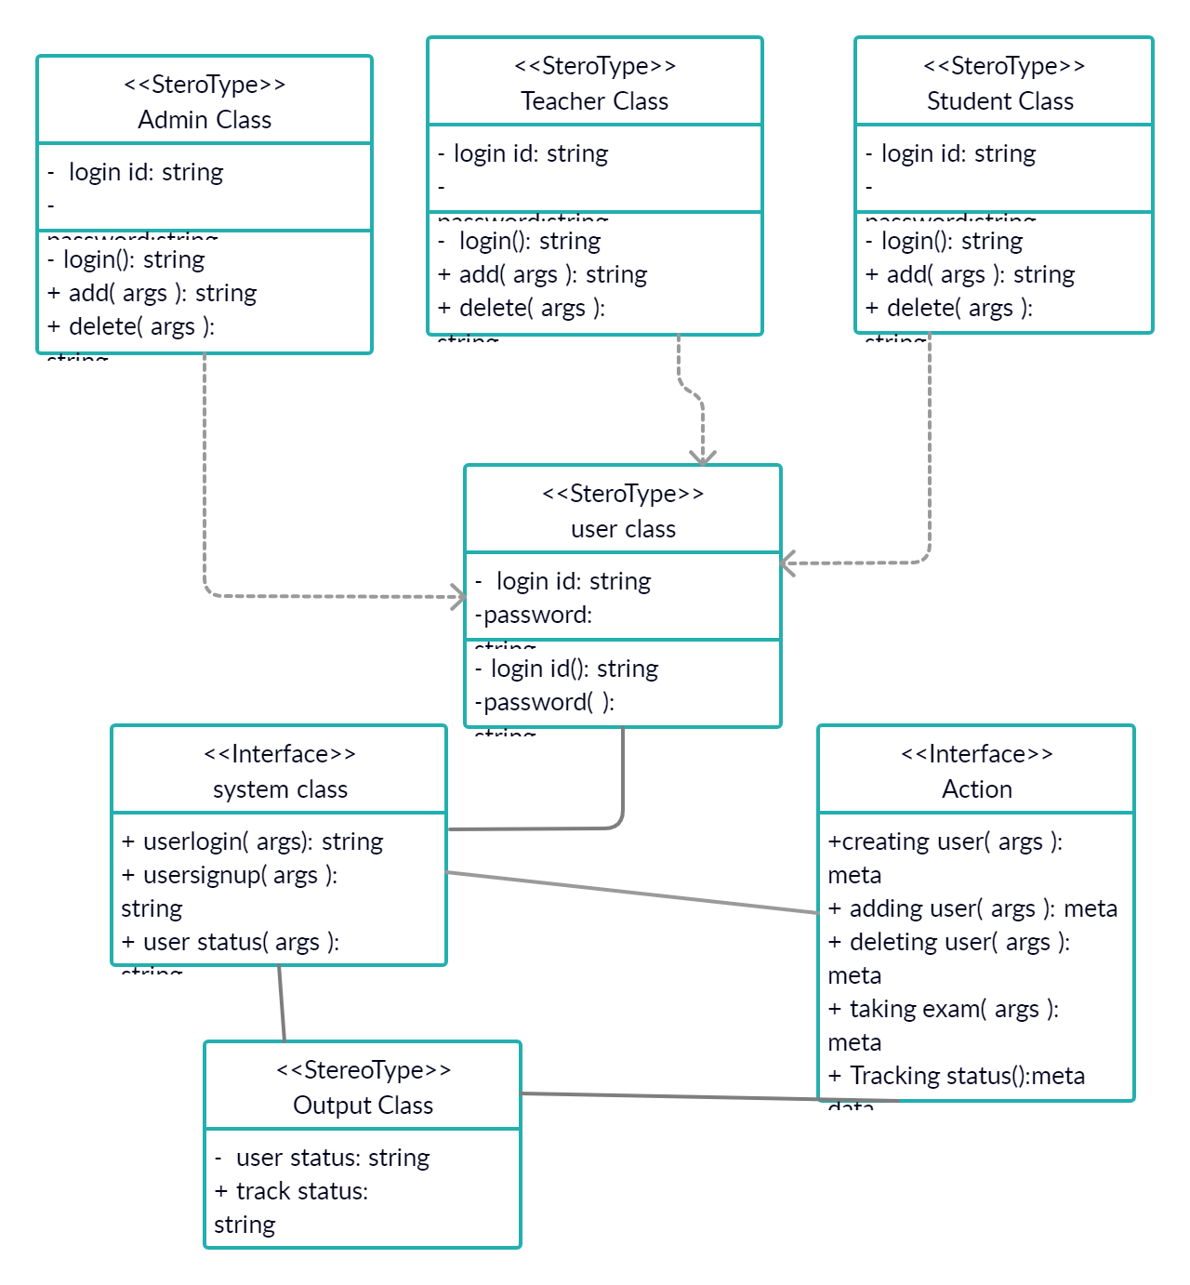

**Sequence Diagram:**

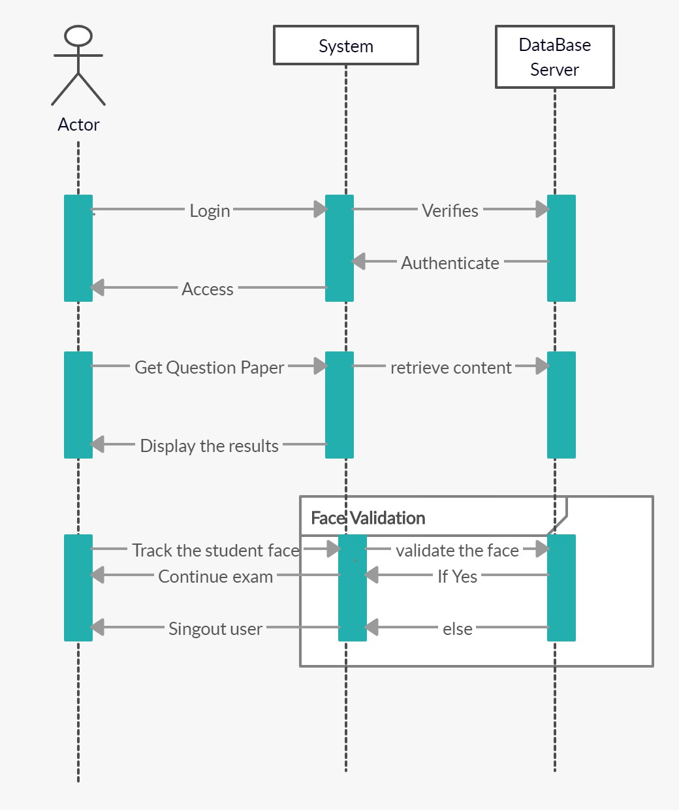

**Testing:**

We have implemented testing for user registration and login, checking the login information of a user and blocking unauthorized user and checking the search bar and user edit options and age drag bar.

The following link of the unit test cases provide complete information on full details of testing done in the increment 1.

The following link is the unit test cases page,

<https://github.com/RoshiniVarada/ASE_PROJECT/blob/master/unit%20testcases.xlsx>

**Implementation:**

First we need to create database in order to create this question paper generating and face tracking system, so we created one data base using firebase storage.

For creating the database you have to create an account in firebase and it will give you an option to create a database for you, you can include your data or create your own database in

There.

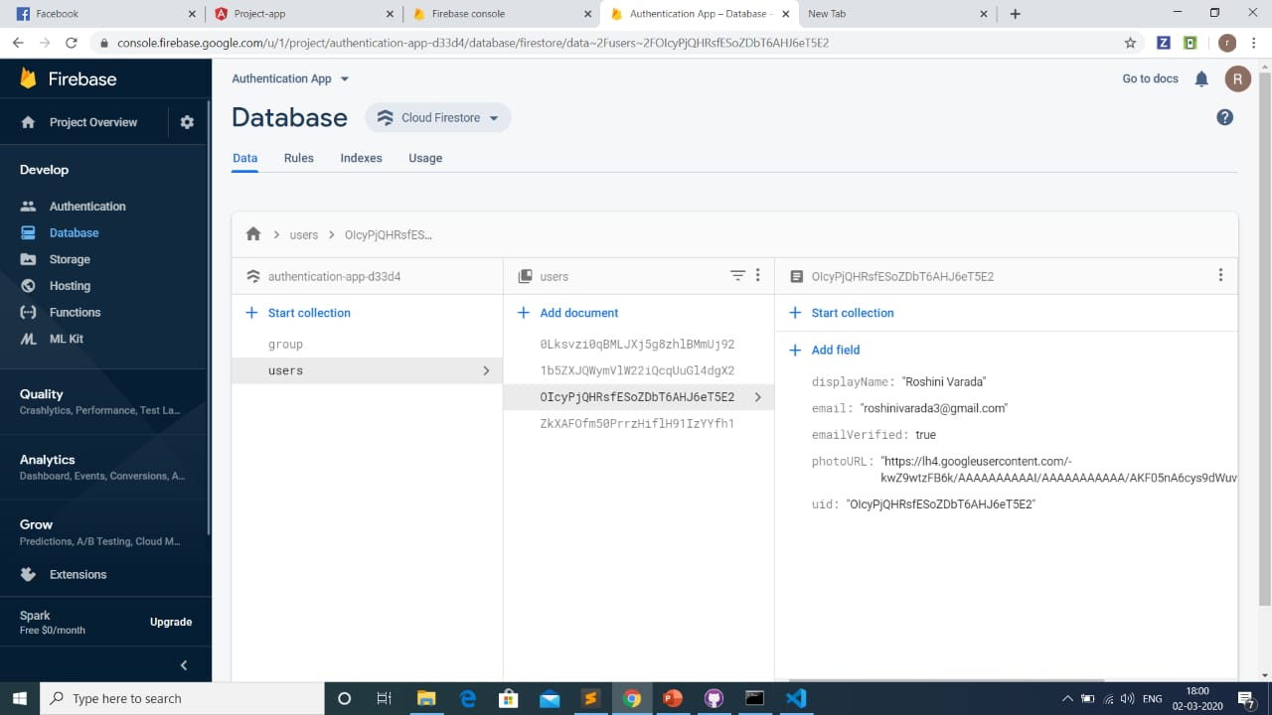

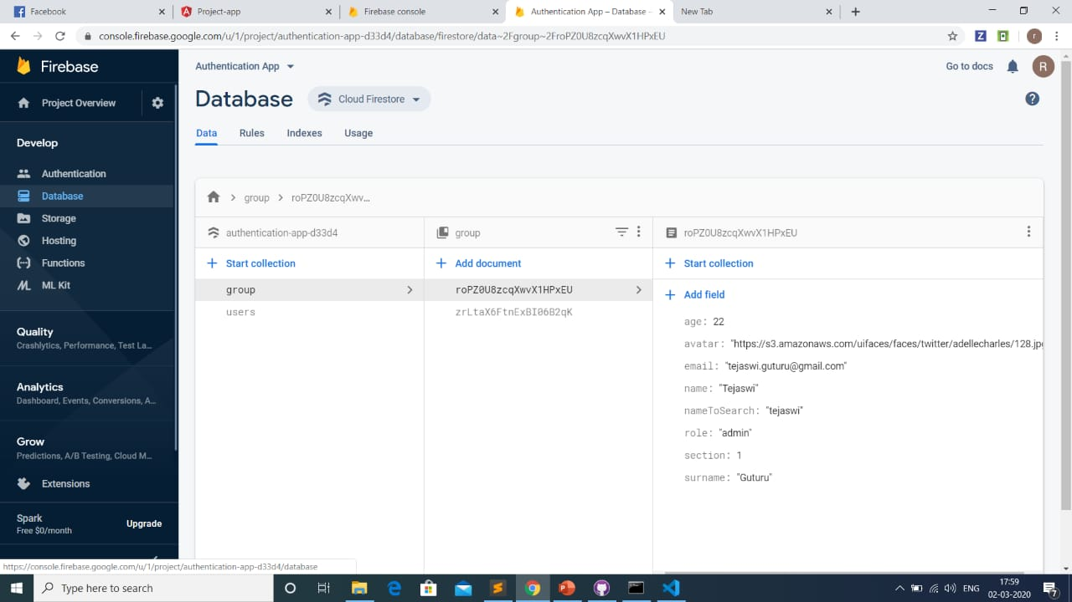

Now, we will see how we created the collection of data using node.js.

**Using NODE.JS:**

Now all the collections that are included in the database are created using node.js, in the database the user data collection and another collection to manage the functions given to user are all created by using node.js.

All the credentials of registered users should be saved to database and when we need those data for re login, we need to retrieve that data from the database, all these are done by using node.js in the backend.

**App development:**

The web app now we developing is used to generate a question paper to students based on the difficulty level, so we are going to create the web app using angular and now we now discuss about the components created to do the application.

First we are creating the login and sign up components, we should create their html, css and typescripts files in order to generate the login and sign up pages.

We can give the user authentication to the login and signup of the app from firebase auth, later now we should create the user profiles, in this project we are going to have three types of users, they are admin, teacher and student.

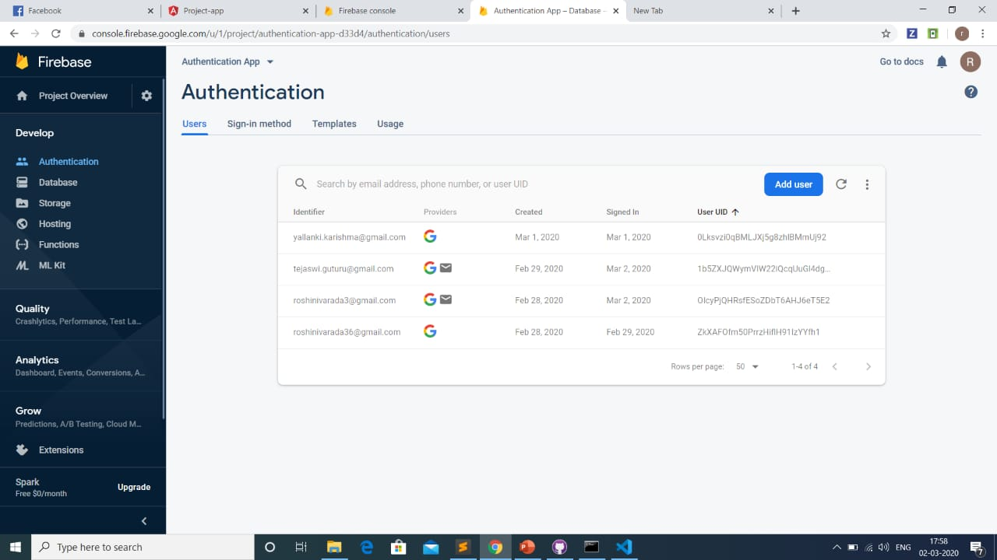

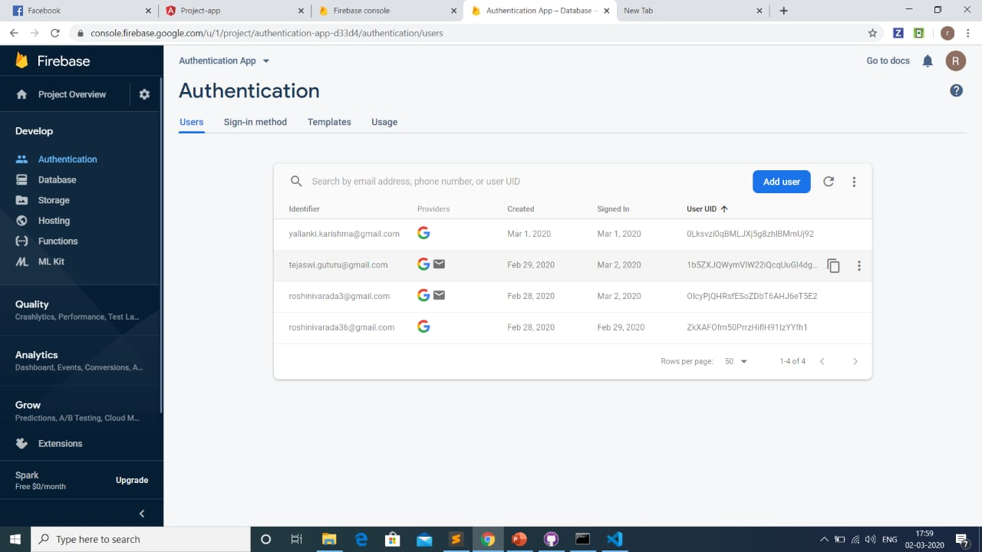

So we should create individual components for each type of user and we created different functions that are associated with different user. we created components for dashboard, edit user, error, home and other.

In this projected we added a feature of searching the user through name and also searching the user through age.

We have a feature to sort out the users into different sections based on their difficulty level.

These are some features that we have included so far and you can see and understand the rest of the information about this web through following images.

The following is the code for different components.

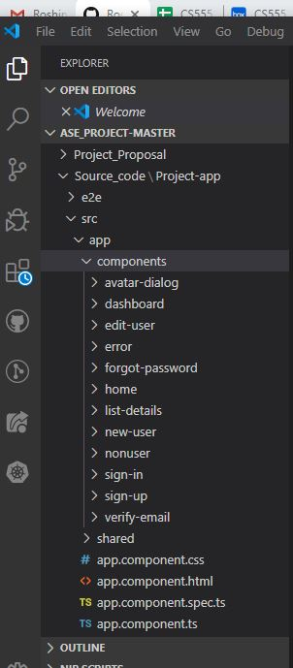

First we need to create an angular app, we sue the command ng create app name, to create an angular app.

In his using ng commands we should create a different components, each component contains one html file and one ts and one css file.

We can create the components through node command window or we can create the, from the code editor it self.

Later that, we should write code for routing In the app and we should create the paths for the data flow.

We will give the authentication to data from app using firebase auth.

After writing all the code we can run this file in the local host port 4200 in our browser.then you can see the output of the app.

**Output and input screenshots:**

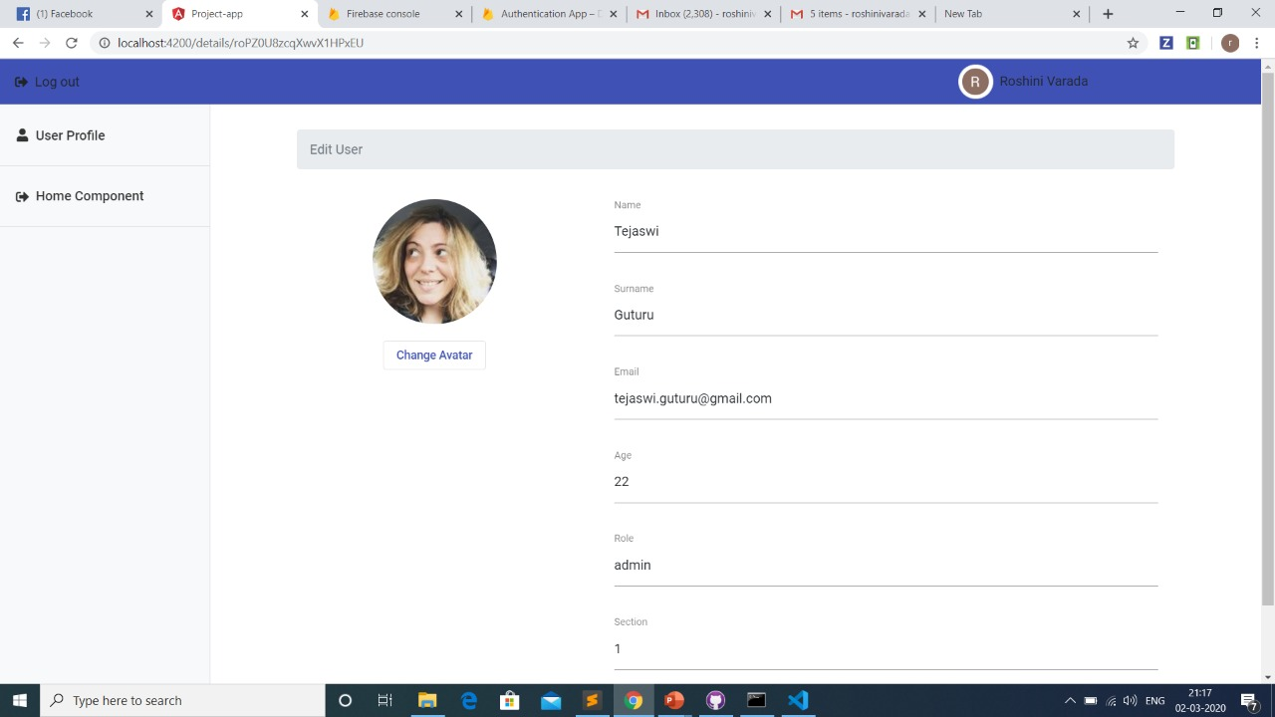

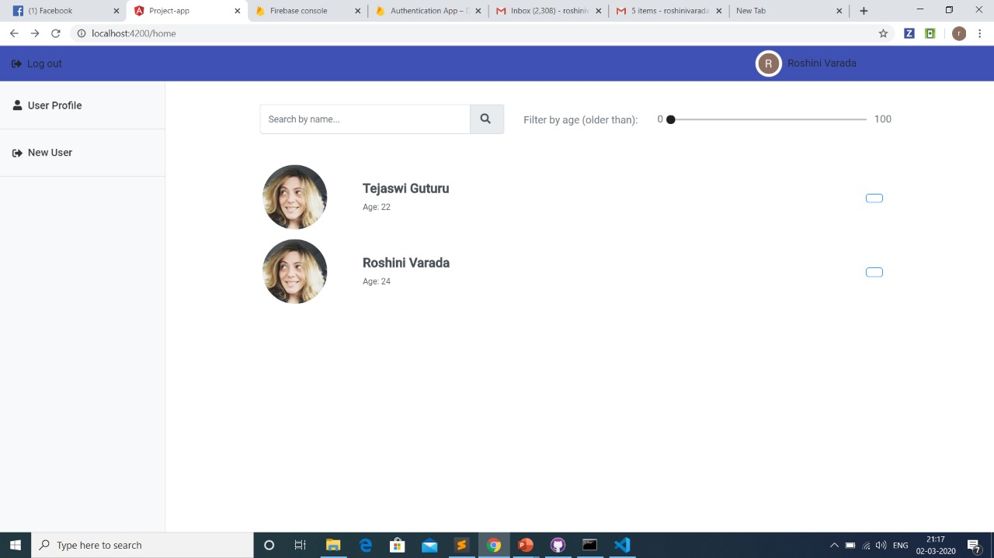

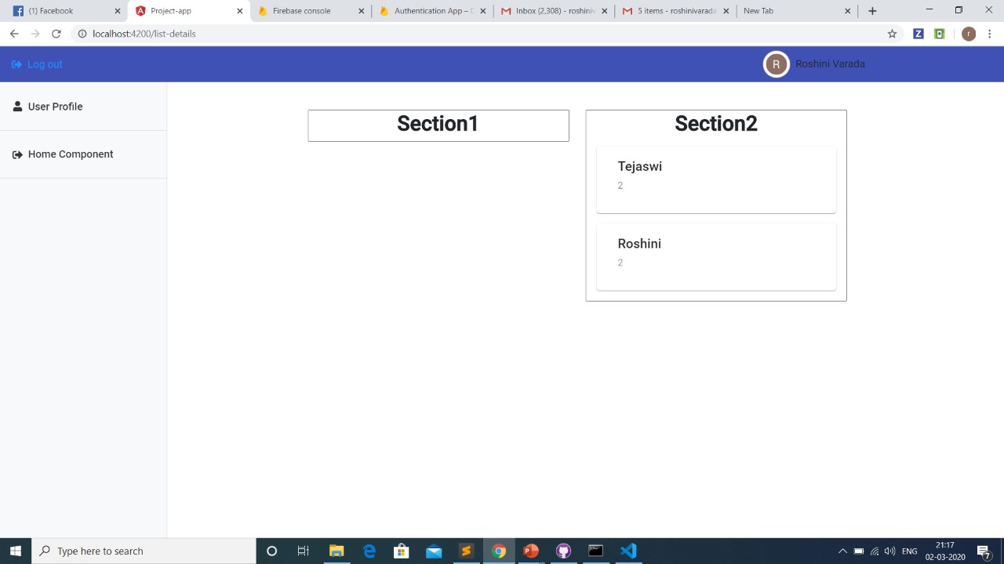

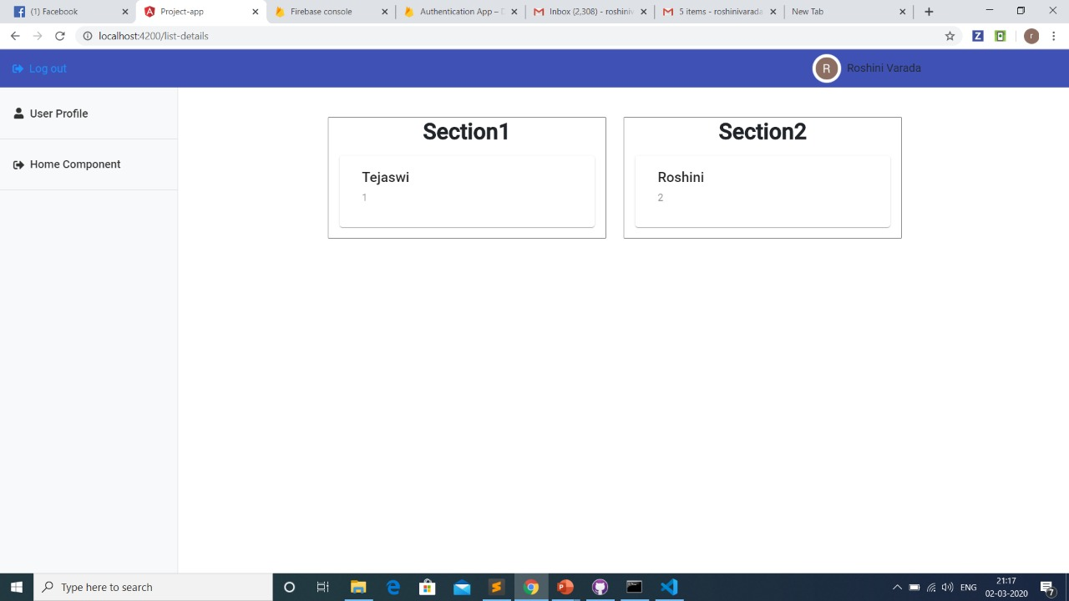

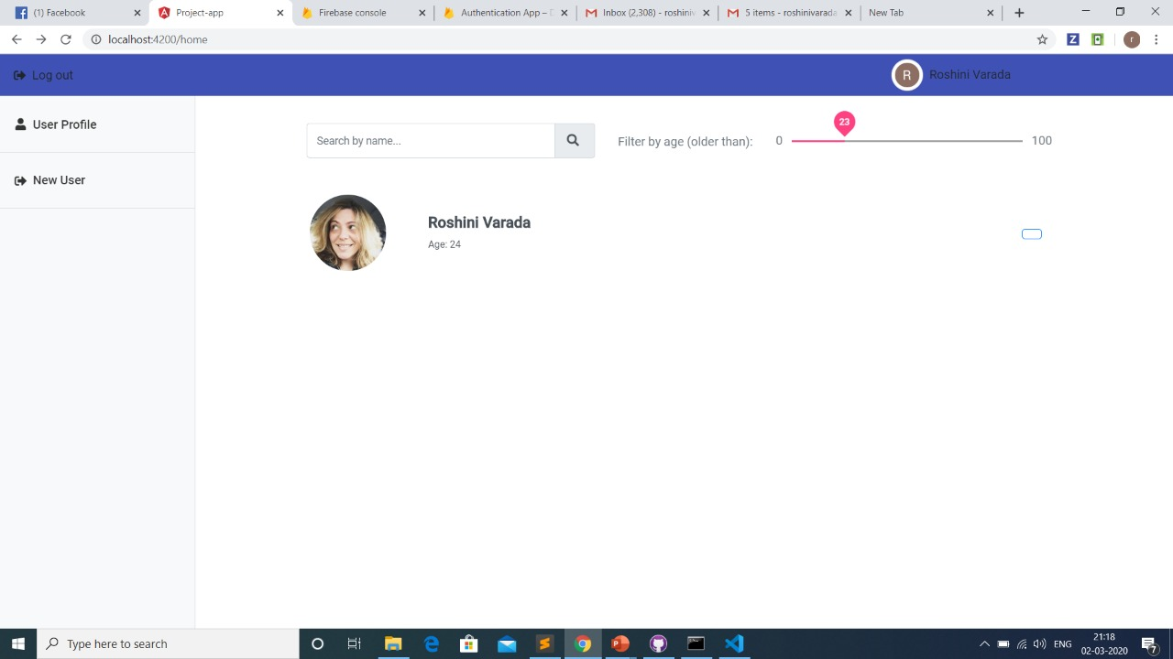

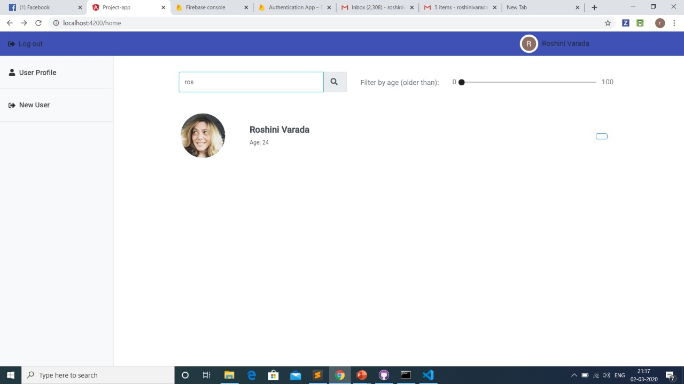

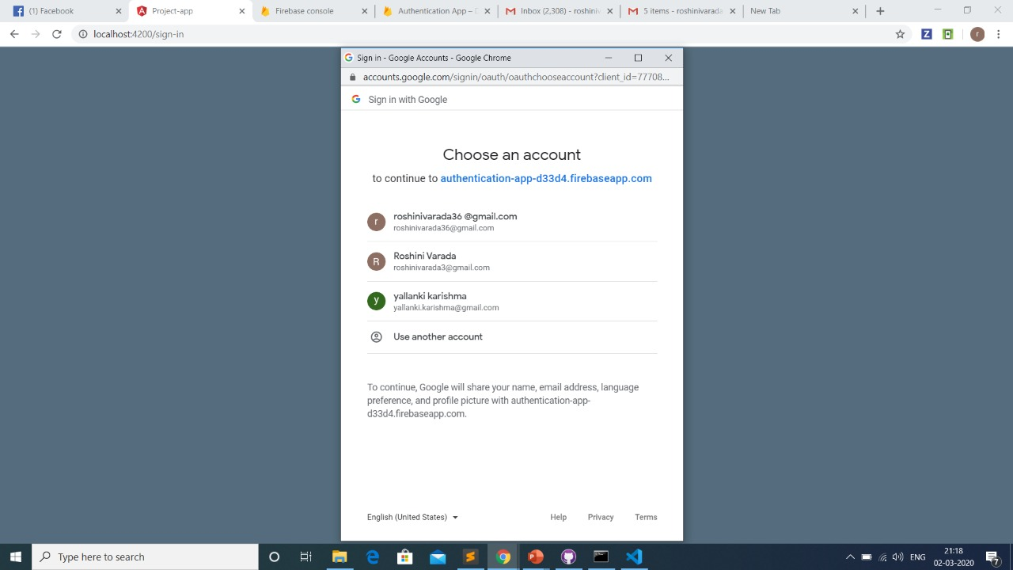

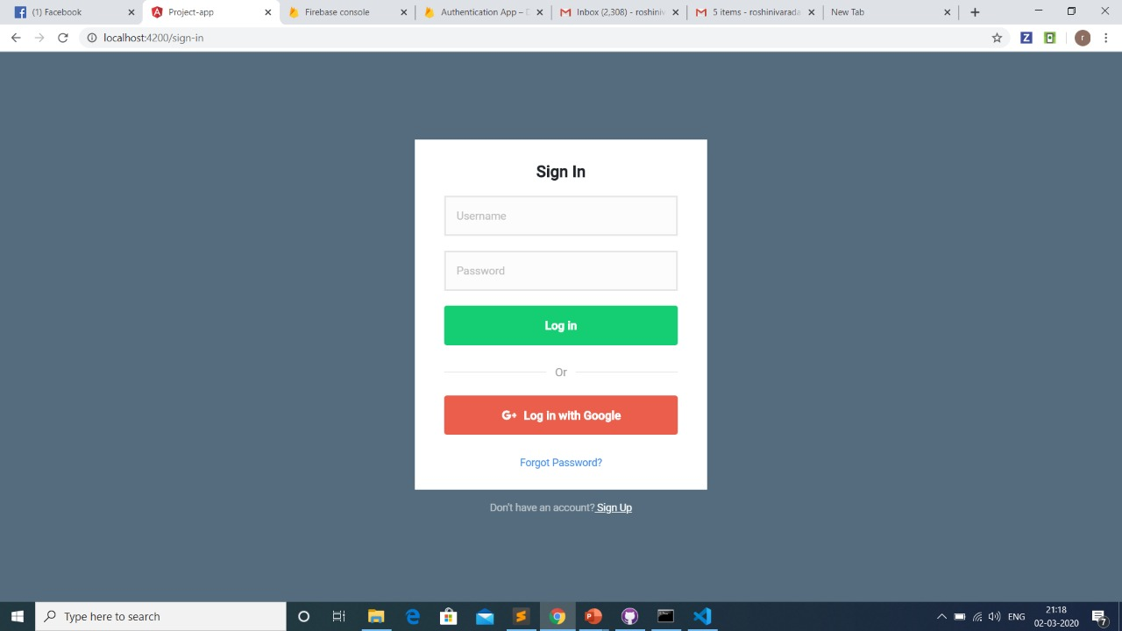

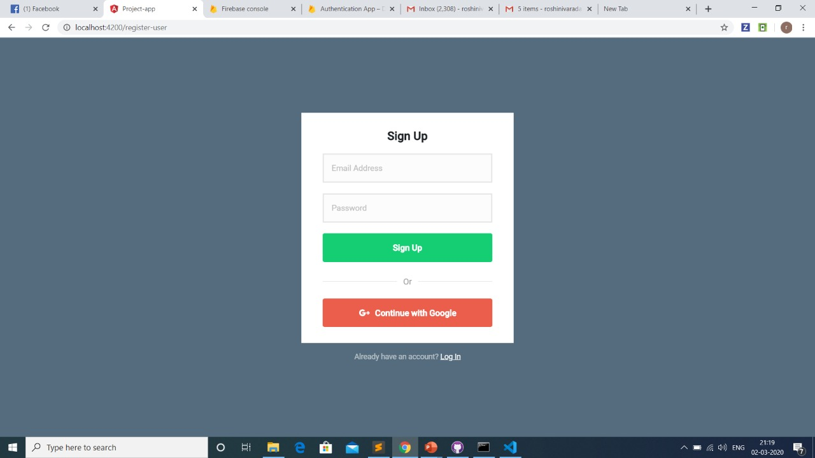

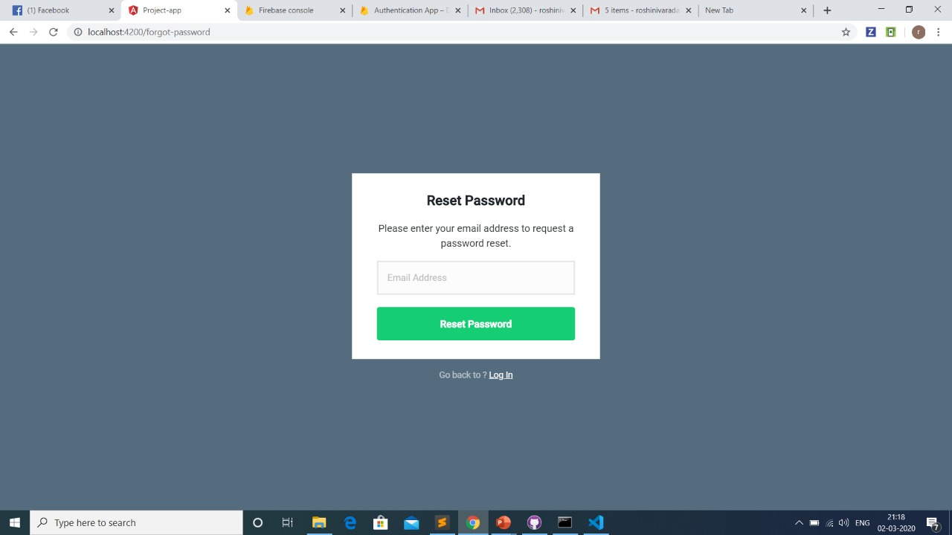





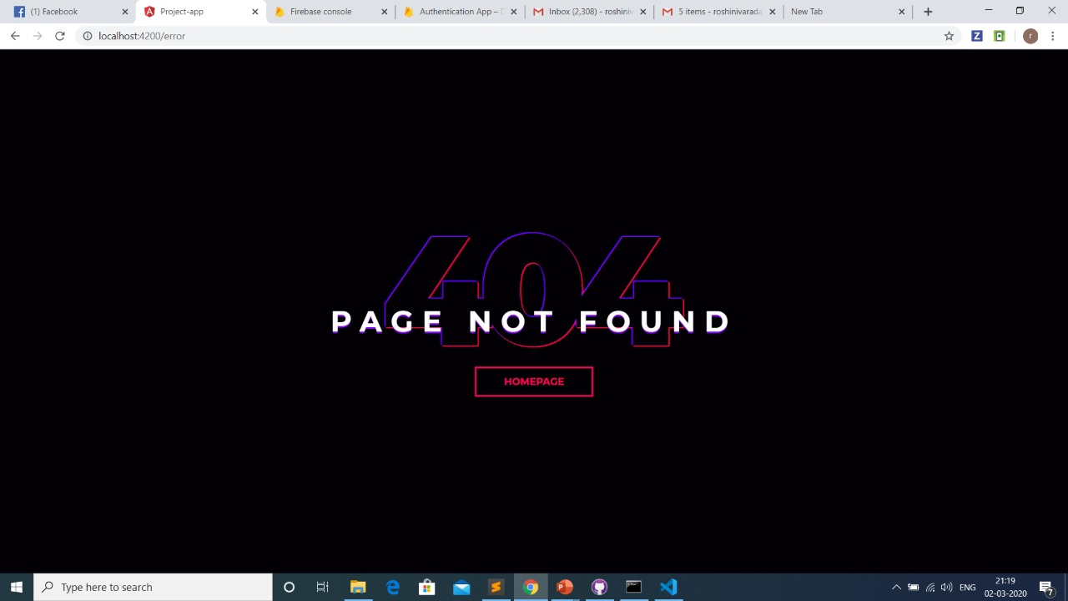

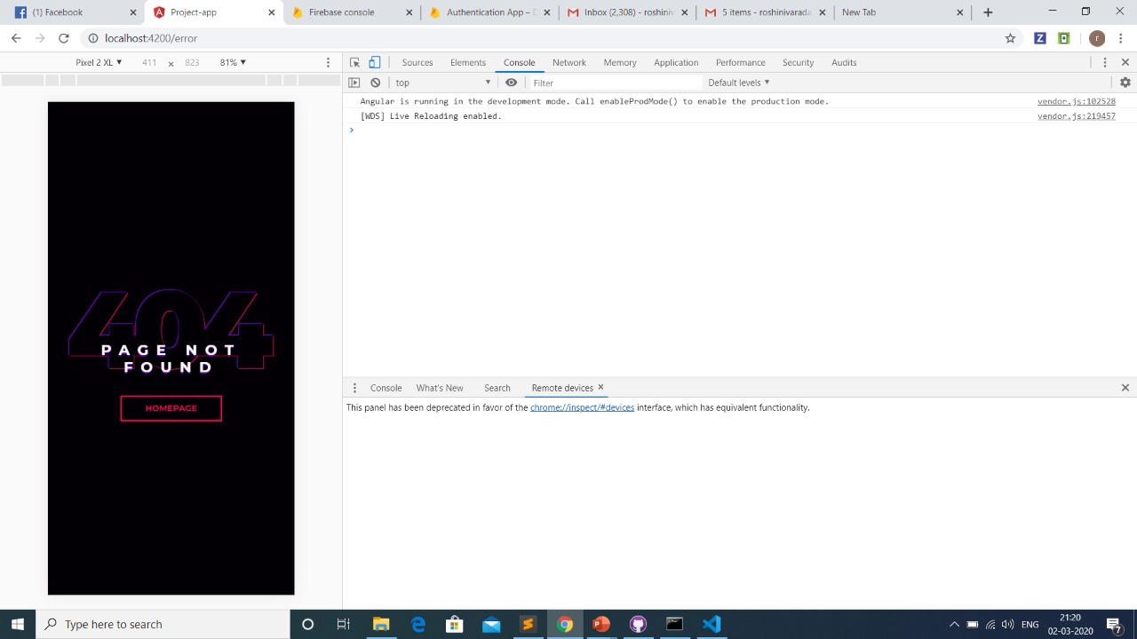

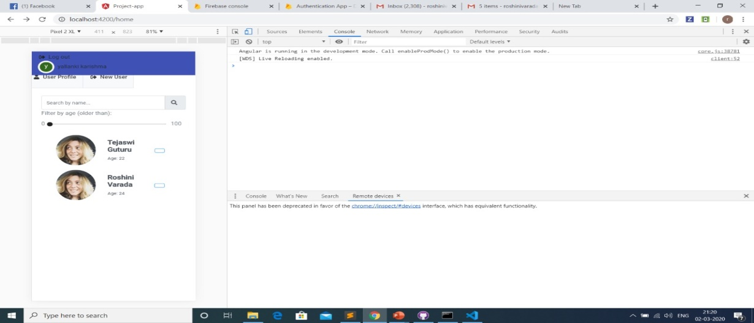

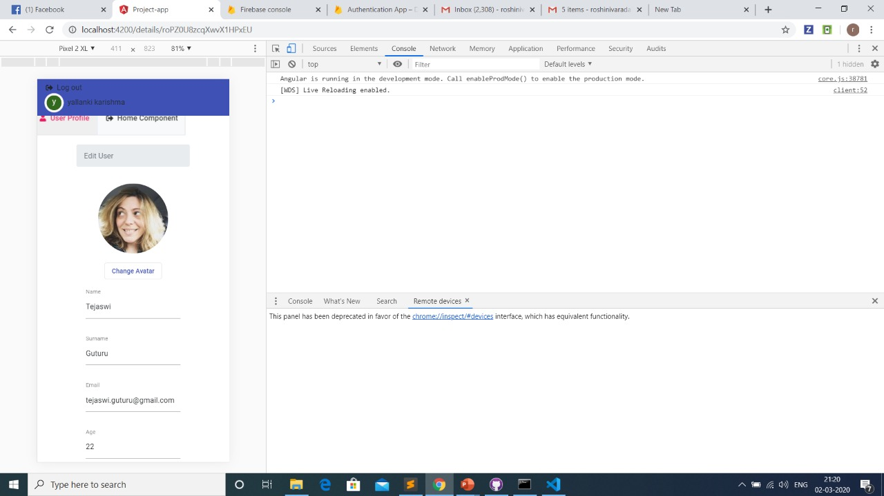



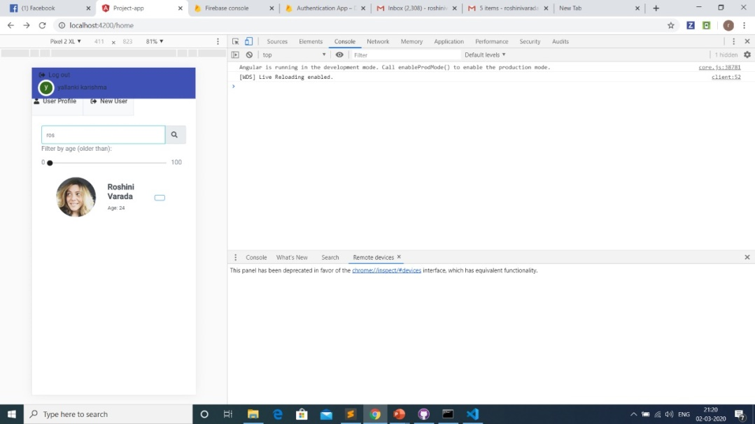

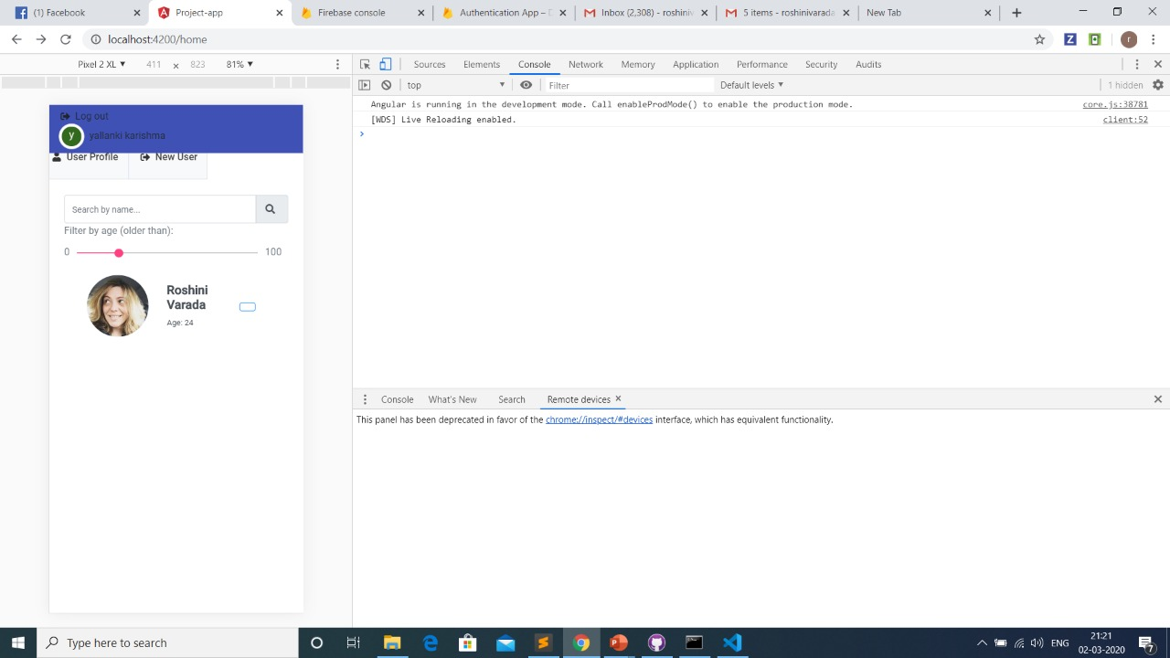

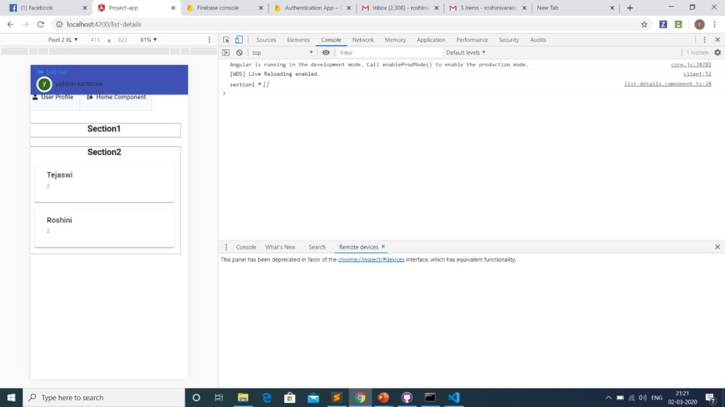

**Project Management:**

**Implementation status report:**

* Created database using firbase.
* Created a web application using ng modules and angular.
* Developed upto user login and sign up and error generation while un registered user trying to login.
* Login in with google+ and navigating it to the select mail page.
* Created user pages,there is an option edit user pages.
* Created search bar.
* Created searching through age bar.
* Feature of sorting out users into different sections is added.
* Deployed into android mobile to see the appearance of the app in mobile.
* 35% of the project is completed in this increment.

**Responsibilities:**

App development and database creation: roshini varada.

API and services: vattem sai pavan

UI: Tejaswi guturu.

UML diagrams and documentation: karishma yallanki.

**.Time taken:**

* One and half day for palnning.
* 3 days to generate databse and app development and including services and api.
* 1 day for UI.
* 1 day to design UML diagrams and write a report.

**References:**

* <https://firebase.google.com/docs/reference/node/firebase.auth>
* <https://firebase.google.com/docs/reference/node/firebase.database>